Calculator Assumed
Applications of Anti-Differentiation 1

Time: 45 minutes
Total Marks: 45
Your Score: / 45



Question One: [3 marks] CA

The area under the curve over the domain is .
Determine the value of k.
Question Two: [2, 2, 3, 3 = 10 marks] CA
Consider the function
- 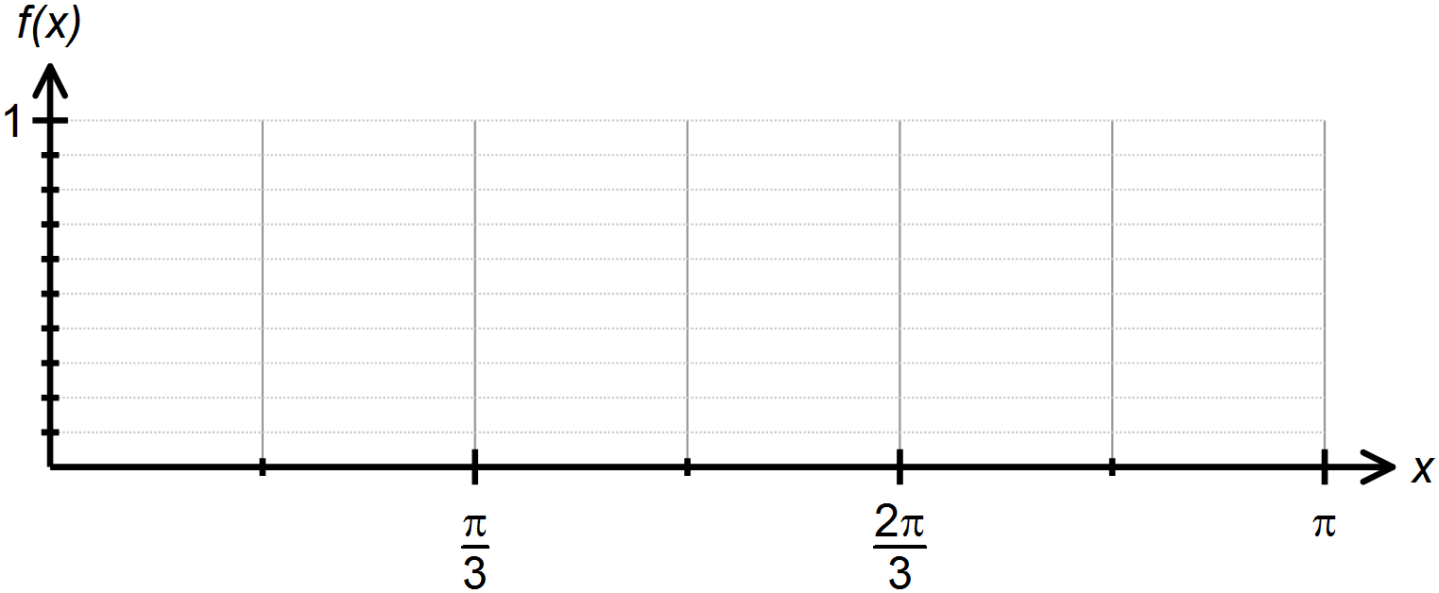Sketch over the domain

- Draw rectangles on your graph that can be used to overestimate the area under over the domain , where .

- Hence approximate the area under the curve over the domain .

- Calculate the margin of error between your answer in part (c) and the exact value of the area under the curve over the domain .

Question Three: [1, 2, 2, 2, 2 = 9 marks] CA
The acceleration of a particle moving in rectilinear motion is given by , where t is time in seconds and is ms⁻². The initial velocity of the particle is -4 m/s.
- Determine the initial acceleration of the particle.

- Determine an expression for the velocity of the particle.

- Calculate when the speed of the particle is 4 m/s.

- Calculate the change in displacement in the first second.

- Calculate the distance travelled in the third second.

Question Four: [2, 2, 3 = 7 marks] CA
The marginal cost of producing x units of a certain product is dollars per unit.
- Determine the extra cost associated with producing the 31st item.

- Find the increase in cost if the production level is increased from 200 units to 500 units.

- The marginal revenue from producing and selling x units of a certain product is . Determine the profit function if the profit from producing 10 items is $38.33.

Question Five: [4 marks] CA
Calculate the area enclosed between the two curves and over the domain .
Draw a sketch to support your solution.

Question Six: [4 marks] CA
The area of the shaded region of below is 6 units².
Determine the values of a and b.
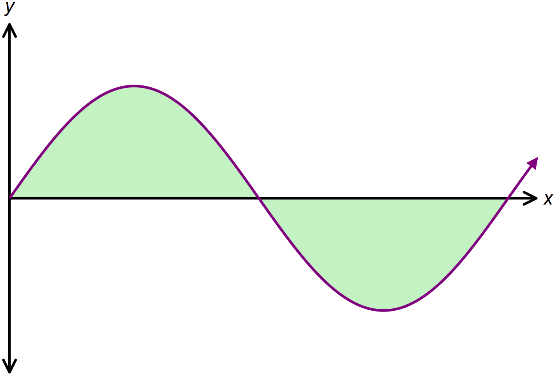

Question Seven: [8 marks] CA
The area bounded by the curve and the x axis over the domain is 10.5 units².
The equation of the tangent to at is .
Determine the values of a, b and c.

SOLUTIONS
Calculator Assumed
Applications of Anti-Differentiation 1

Time: 45 minutes
Total Marks: 45
Your Score: / 45



Question One: [3 marks] CA

The area under the curve over the domain is .
Determine the value of k.



Question Two: [2, 2, 3, 3 = 10 marks] CA
Consider the function
- 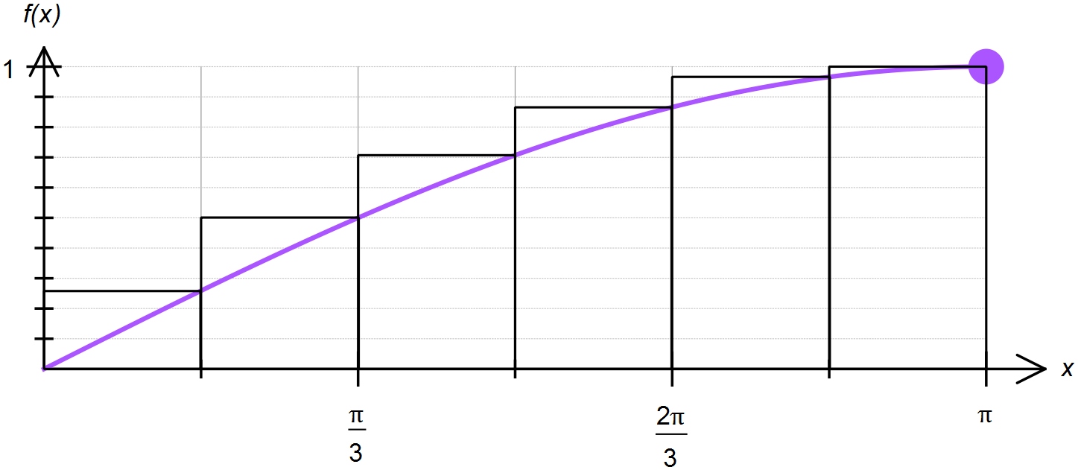Sketch over the domain







- Draw rectangles on your graph that can be used to overestimate the area under over the domain , where .

- Hence approximate the area under the curve over the domain .




- Calculate the margin of error between your answer in part (c) and the exact value of the area under the curve over the domain .



Question Three: [1, 2, 2, 2, 2 = 9 marks] CA
The acceleration of a particle moving in rectilinear motion is given by , where t is time in seconds and is ms⁻². The initial velocity of the particle is -4 m/s.

- Determine the initial acceleration of the particle.
- Determine an expression for the velocity of the particle.




- Calculate when the speed of the particle is 4 m/s.


- Calculate the change in displacement in the first second.



- Calculate the distance travelled in the third second.


Question Four: [2, 2, 3 = 7 marks] CA
The marginal cost of producing x units of a certain product is dollars per unit.

- Determine the extra cost associated with producing the 31st item.


- Find the increase in cost if the production level is increased from 200 units to 500 units.



- The marginal revenue from producing and selling x units of a certain product is . Determine the profit function if the profit from producing 10 items is $38.33.



Question Five: [4 marks] CA
Calculate the area enclosed between the two curves and over the domain .
Draw a sketch to support your solution.




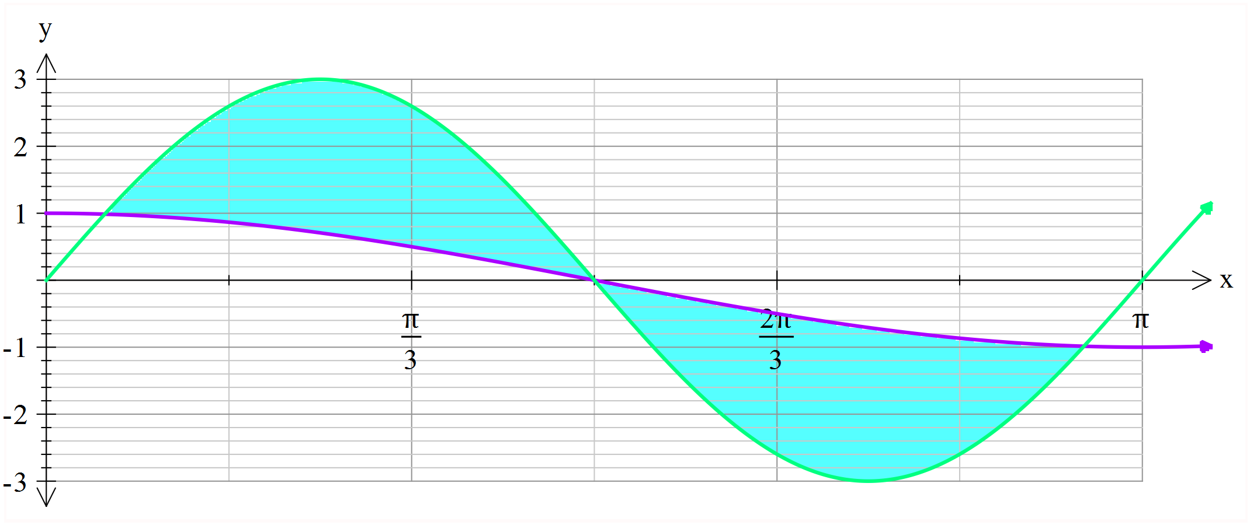

Question Six: [4 marks] CA
The area of the shaded region of below is 6 units².
Determine the values of a and b.





Question Seven: [8 marks] CA
The area bounded by the curve and the x axis over the domain is 10.5 units².
The equation of the tangent to at is .

Determine the values of a, b and c.








